Oseh Shalom Presents Judaism and the Environment
  - Sunday January 9, 2022
Join us for one or all of the events that highlight Jewish concern for the Environment

10:15 AM Why Plant Natives? National Wildlife Federation biologist, Naomi Edelson, describes the power of planting native plants at our homes and synagogue. This hybrid webinar allows people to attend in-person at Oseh Shalom and on-line via Zoom.

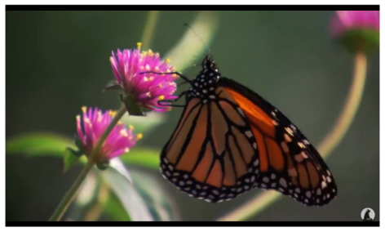
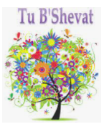
  - 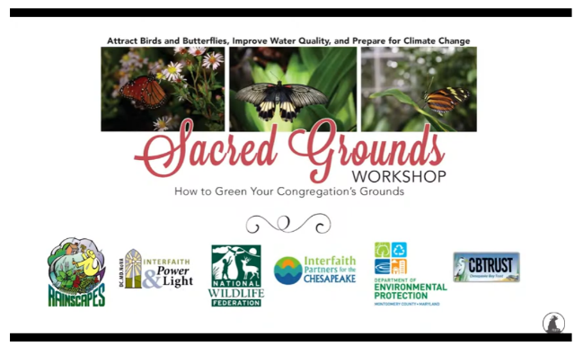
11:30 AM Tu B’Shevat Activities. Parents, children and congregants can participate in interactive activities to learn about the Jewish New Year of the Trees.

12:00 PM – 12:30 PM Lunch. Bring lunch food for yourself or to share. Eat in the Social Hall or outside around a firepit!

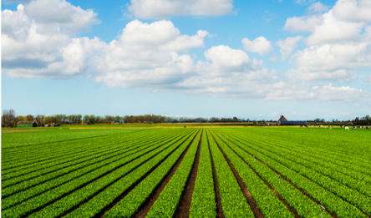
12:30 PM – 2:00 PM Shmita. Join Rabbinic Intern Faryn Borella for an experiential workshop on how the Jewish practice of Shmita can personally and collectively inform our lives.
